|  |
| --- |
| **Smart Public restroom** |
| Project Report |

# Overview

## Project Objectives :

|  |  |
| --- | --- |
|  | The Smart Public Restroom project aims to revolutionize public restroom facilities by leveraging Internet of Things (IoT) technology. The primary objectives include:  1. Enhancing Accessibility: To provide real-time information about the availability and cleanliness of public restrooms, ensuring that people can find and access clean facilities conveniently.  2. Improving Hygiene: To promote better restroom hygiene by monitoring cleanliness and enabling users to make informed choices.  3. Efficient Management: To offer restroom facility managers real-time data to optimize maintenance and operations, leading to cost savings and improved user satisfaction. |

## IoT Sensor Setup :

|  |  |
| --- | --- |
|  | 1. Occupancy Sensors: Infrared occupancy sensors detect when individuals enter and exit restroom stalls.  2. Cleanliness Sensors: IoT cameras with computer vision algorithms evaluate the cleanliness of restroom fixtures and surfaces.  3. Environmental Sensors: Sensors for temperature and humidity monitor the restroom environment for comfort and sanitation. |

## Sensor Schematic :

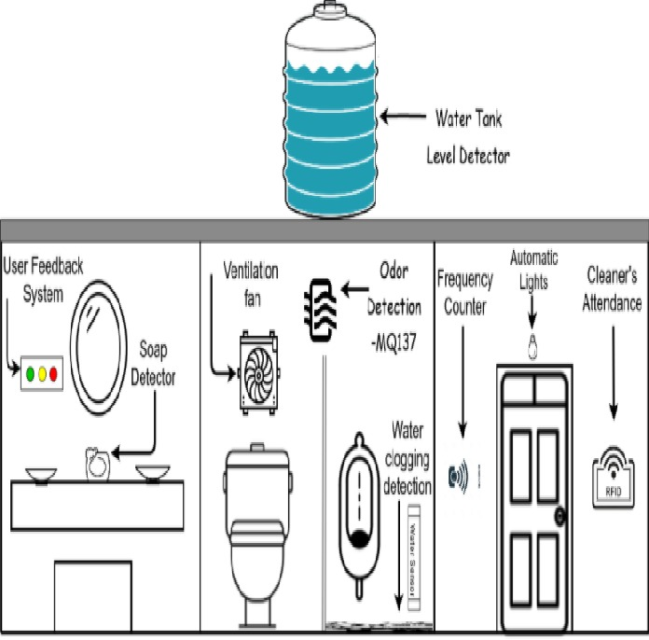

## Mobile App Development :

A mobile application was developed for both Android and iOS platforms using Flutter for cross-platform compatibility. The app offers the following key features:

1. Real-time Availability: Users can view the availability status of nearby public restrooms on a map.

2. Cleanliness Ratings: Users can provide and view cleanliness ratings for each restroom.

3. Directions: The app provides directions to the nearest available public restroom.

## Raspberry Pi Integration :

Raspberry Pi serves as a central hub for data collection and transmission from IoT sensors to the cloud. It is connected to the sensors and runs Python scripts for data processing and transmission.

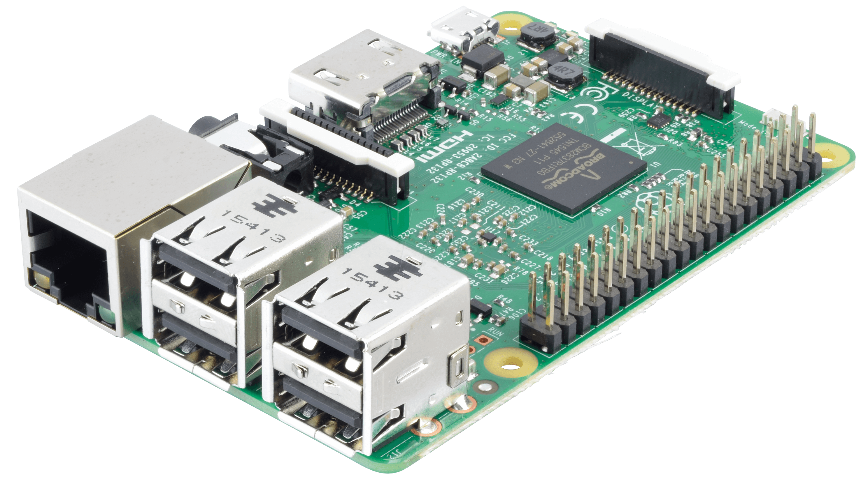

[This Photo](https://www.electronics-lab.com/raspberry-pi-tutorial-beginners-guide-thepihut-com/) by Unknown Author is licensed under [CC BY-SA](https://creativecommons.org/licenses/by-sa/3.0/)

## Code Implementation :

1. IoT Sensor Code: Scripts to collect data from occupancy, cleanliness, and environmental sensors.

2. Raspberry Pi Code: Python code running on the Raspberry Pi for data processing and transmission.

3. Mobile App Code: Flutter code for the mobile app's user interface and real-time data retrieval.

## Python code:

import paho.mqtt.client as mqtt

import time

# Set up MQTT client and connect

mqtt_client = mqtt.Client()

mqtt_client.connect("test.mosquitto.org", 1883)

# Get occupancy reading

occupancy = get_occupancy()

# Add timestamp

current_time = time.time()

data = {"occupancy": occupancy, "timestamp": current_time}

# Perform some processing

data["percent_full"] = calculate_percent_full(occupancy)

# Publish data to MQTT topic

mqtt_client.publish("restroom/occupancy", json.dumps(data))

## 10. Enhancement of User Experience and Restroom Management:

1. Improved User Experience: Users can quickly find clean and available restrooms, reducing wait times and improving the overall restroom experience.

2. Enhanced Restroom Management: Facility managers gain insights into usage patterns and cleanliness data, allowing for efficient maintenance and resource allocation.

3. Hygiene Promotion: By providing cleanliness ratings, the system encourages restroom users to maintain cleanliness standards.

**Conclusion:**

The Smart Public Restroom project successfully utilizes IoT technology to enhance public restroom accessibility, cleanliness, and user experience. By providing real-time information and empowering users to make informed choices, it not only improves convenience but also contributes to more efficient restroom management.

***Submitted By:***

* Karthikeyan S
* Aswin Jebas R
* Deepak G
* Harissh J
* Hari Prakash G